Notice of DPA Submission

East 15
04-Jun-2020

Table of Contents
Notice of DPA Submission 1
Table of Contents 2
Simulation Assumptions 3
Antenna Model--Antenna1 4
DPA: East 15 5
ESC Site Information 5
ESC Combinations-DPA Coverage 5
ESC-DPA Coverage Map(s) 5

Simulation Assumptions

210dB used as the path loss threshold.
ITM 50% Confidence and 95% Reliability used to calculate path loss thresholds to locations within 75km from the shore.
ITM 50% Confidence and 50% Reliability used to calculate path loss thresholds for the remainder of the DPA area.
DPA grid spacing set to 100km.

Antenna Model--Antenna1

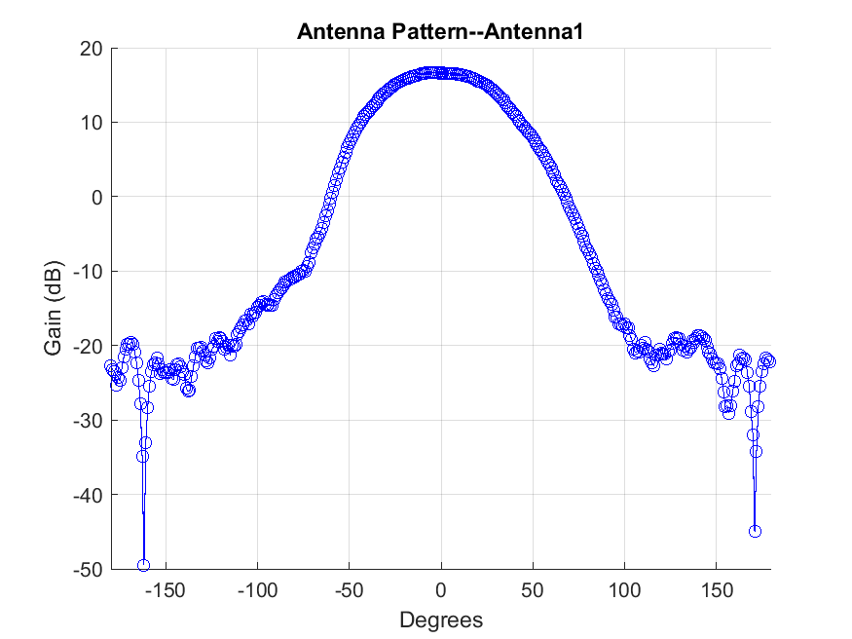

DPA: East 15

ESC Site Information
ESC Name | Latitude (DD) | Longitude (DD) | ESC Height (m) | Azimuth (deg) | Antenna Beam width (deg) | Antenna Gain (dBi) | Cable Loss (dB) | Antenna Name
ESC1 | 27.5 | -80.4 | 50 | 116 | 60 | 16.67 | 3 | Antenna1
ESC2 | 26.5 | -80 | 50 | 45 | 60 | 16.67 | 3 | Antenna1

ESC Combinations-DPA Coverage
DPA | ESC | ESC | Coverage: 95% | Coverage: 50%
East 15 | ESC1 | ESC2 | 100% | 100%

ESC-DPA Coverage Map(s)
